**We have a Letter or a word then we need add some letters to it and need to find out shortest palindrome For example we take "S": S will be the shortest palindrome string. If we take "xyz": zyxyz will be the shortest palindrome string So we need to add some characters to the given string or character and find out what will be the shortest palindrome string by using simple java program.**

**package** Tuesday;

**import**java.util.Scanner;

**publicclass**ShortestPalindromeDemo {

**publicstatic** String shortestPalindrome(String str) {

**int**x=0;

**int**y=str.length()-1;

**while**(y>=0){

**if**(str.charAt(x)==str.charAt(y)){

x++;

}

y--;

}

**if**(x==str.length())

**return**str;

String suffix = str.substring(x);

String prefix = **new** StringBuilder(suffix).reverse().toString();

String mid = *shortestPalindrome*(str.substring(0, x));

**return**prefix+mid+suffix;

}

**publicstaticvoid** main(String[] args) {

Scanner in = **new** Scanner(System.***in***);

System.***out***.println("Enter a String to find out shortest palindrome");

String str=in.nextLine();

System.***out***.println("Shortest palindrome of "+str+" is "+*shortestPalindrome*(str));

}

}

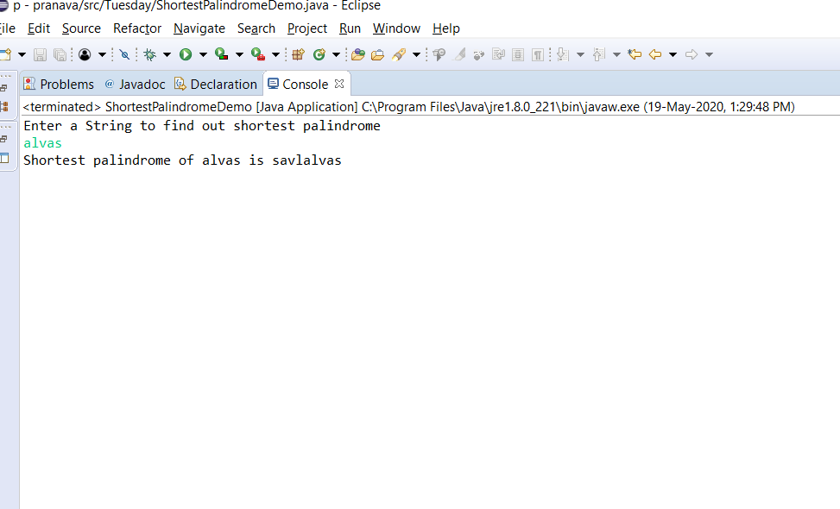

OUTPUT